Hands-on 1:
Design Pattern and Principles :

Exercise 1 : Implementing the singleton pattern:

public class Logger {

private static Logger instance;

private Logger() {
System.out.println("Logger Instance Created");
}

public static Logger getInstance() {

if (instance == null) {
instance = new Logger();
}

return instance;
}

public void log(String message) {
System.out.println("LOG: " + message);
}
}
Main class:
public class SingletonTest {

public static void main(String[] args) {

Logger logger1 = Logger.getInstance();

logger1.log("Application Started");

Logger logger2 = Logger.getInstance();

logger2.log("User Logged In");

if (logger1 == logger2) {
System.out.println("Only one Logger instance exists.");
}
}
}
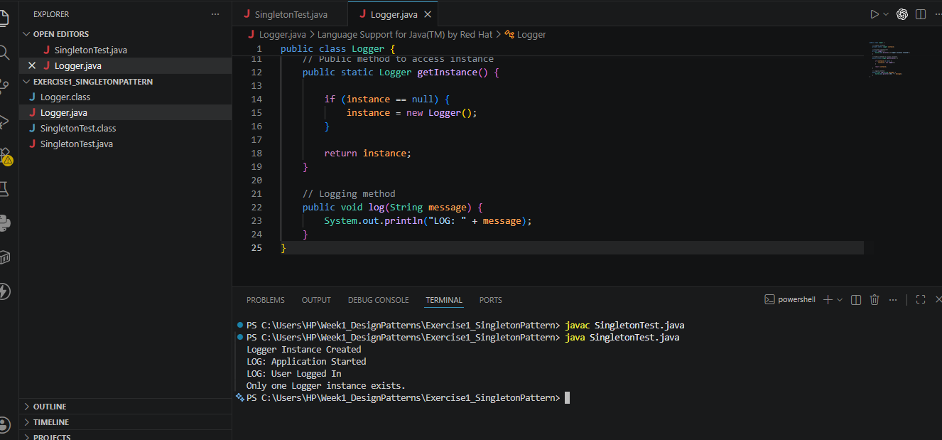

Exercise 2: Implementing the Factory Method Pattern :

Document.java:
public interface Document {
void open();
}
WordDocument.java:
public class WordDocument implements Document {

public void open() {
System.out.println("Opening Word Document");
}
}
PdfDocument.java:
public class PdfDocument implements Document {

public void open() {
System.out.println("Opening PDF Document");
}
}
ExcelDocument.java
public class ExcelDocument implements Document {

public void open() {
System.out.println("Opening Excel Document");
}
}
DocumentFactory.java
public abstract class DocumentFactory {

public abstract Document createDocument();
}
WordDocumentFactory.java
public class WordDocumentFactory extends DocumentFactory {

public Document createDocument() {
return new WordDocument();
}
}
PdfDocumentFactory.java
public class PdfDocumentFactory extends DocumentFactory {

public Document createDocument() {
return new PdfDocument();
}
}
ExcelDocumentFactory.java
public class ExcelDocumentFactory extends DocumentFactory {

public Document createDocument() {
return new ExcelDocument();
}
}
FactoryMethodTest.java
public class FactoryMethodTest {

public static void main(String[] args) {

DocumentFactory wordFactory =
new WordDocumentFactory();

Document wordDoc =
wordFactory.createDocument();

wordDoc.open();

DocumentFactory pdfFactory =
new PdfDocumentFactory();

Document pdfDoc =
pdfFactory.createDocument();

pdfDoc.open();

DocumentFactory excelFactory =
new ExcelDocumentFactory();

Document excelDoc =
excelFactory.createDocument();

excelDoc.open();
}
}
